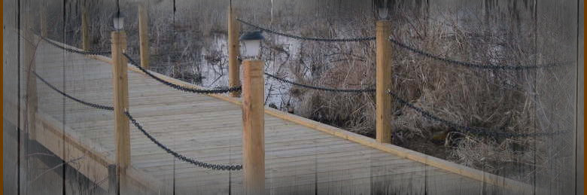
MN Boardwalks, L.L.C. is a company based out of central Minnesota, providing services to Minnesota, North Dakota, South Dakota, Iowa, Wisconsin and Northern Illinois.
Our boardwalk will allow you to enjoy a walk through nature; or drive your ATV, golf cart or 4-wheeler over wetlands, lowlands, marshes, ponds, etc. Turn unusable land into something enjoyable.

If you are in care of: Golf Courses, Campgrounds, Resorts, Park Departments, Hunt Clubs, Wildlife Groups, Lake Associations, DNR Projects, Biking, Hiking or Walking Trails or, if you are a Developer or Waterfront Owner, use a MN Boardwalk system to upgrade your cart bridges, lakefront, walking trails or to access unusable land. Make your business or property safe and worry free for people to enjoy. Let MN Boardwalks help you with whatever walk of nature you have in mind.
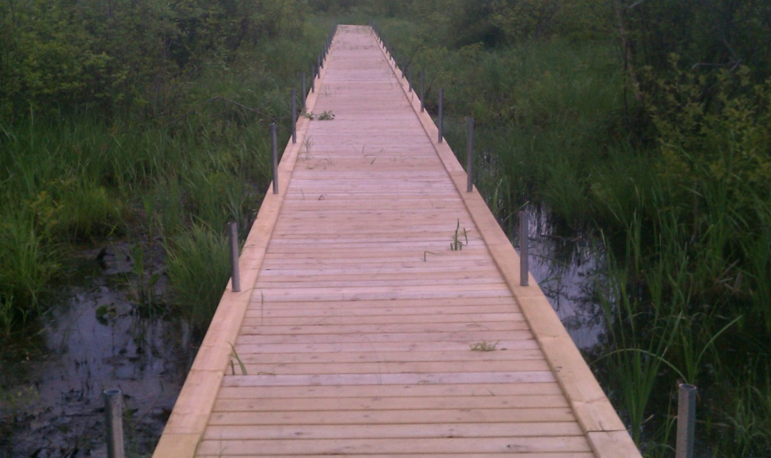
Five foot wide boardwalk, through a wetland Elevated Observation Platform
Both of the above were funded in part by the MN Parks and Trails Legacy Grant Program.
Ask about our new Fishing Piers and Public Access Floating Docks. Please contact us for details.

MN Boardwalks, LLC
www.MNBoardwalks.com
tls21372@gmail.com
612-270-2694

